United Way Wheel of Fortune
Work with your United Way contact to coordinate a fun, educational game of United Way Wheel of Fortune. The game is administered through a simple-to-use PowerPoint, either in-person or through a virtual platform like Zoom or Webex. United Way themed puzzles and educational blurbs can be used as-is or can be further customized to fit your needs.
Two ways to play:
- Toss-up style puzzles only
  - Use in an existing meeting as an icebreaker or interactive UW educational presentation
  - Flexible timing based on how many puzzles you choose
  - 10-15 minutes for 5 puzzles
  - No pre-determined players needed, entire group plays as one player
- Traditional Game
  - Best as a stand-alone event or fundraiser unless you reduce to ~3 puzzles
  - Flexible timing based on how many puzzles you choose (15 minutes - 1 hour)
  - Pre-determined players needed, up to 6 maximum

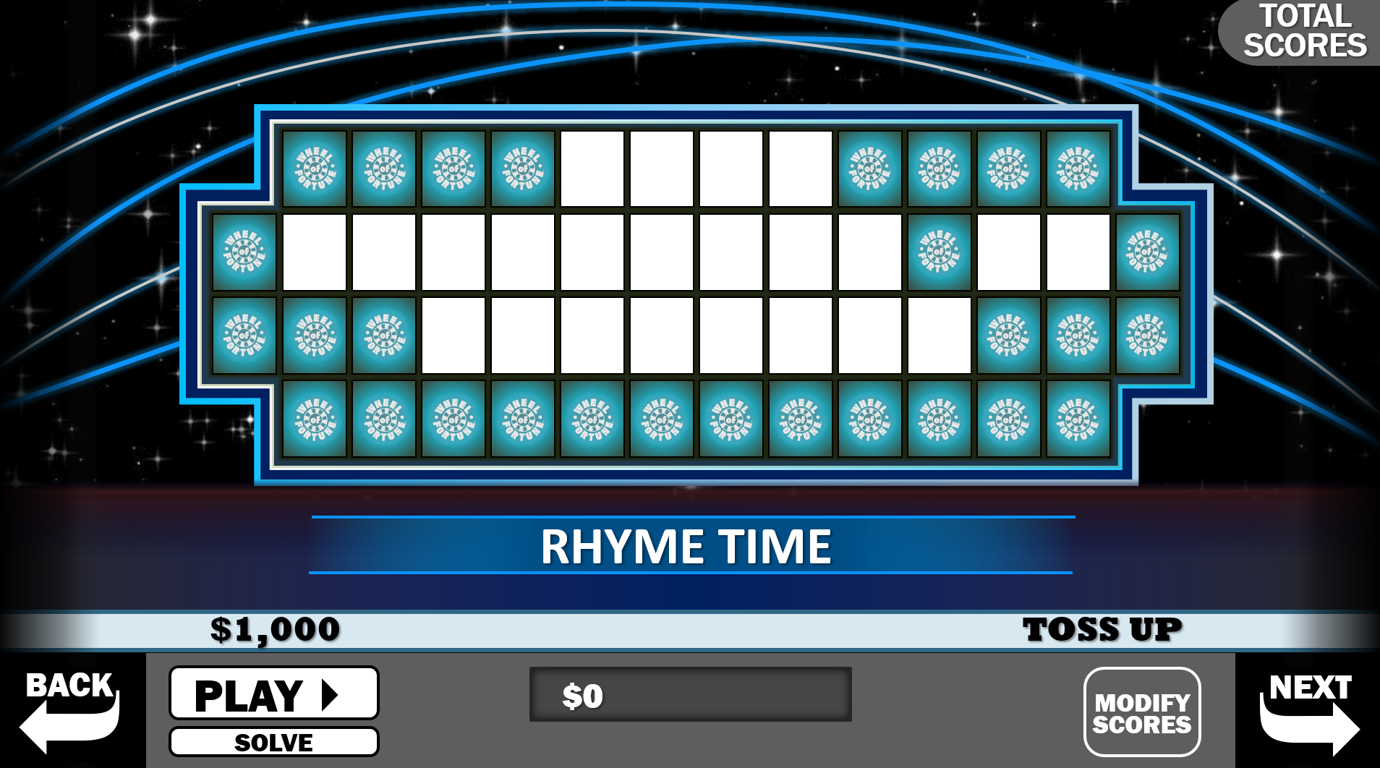
Download the Game under Activities: https://unitedwayhouston.org/workplace-giving/materials-tools-toolkits/
Facilitator Answer Guide and Educational Blurbs

Description of Categories:
Before & After – Consists of two phrases, names, etc. combined by a word that ends the first and starts the second (e.g., WHEEL OF FORTUNE COOKIE)
Person – does not necessarily mean proper name
Rhyme Time – a phrase with rhyming words in it (e.g. WINE AND DINE)
Same Letter – a phrase with each word beginning with the same consonant
What are you doing? – an activity

Puzzles:

Toss up Style
Category: Phrase
Answer: CONNECTING PEOPLE TO POSSIBILITY
Educational Blurb to mention: This past year, United Way of Greater Houston refreshed our brand to better reflect how we work with our community to connect people to possibility. Our new brand has been recognized with three ADDY Awards and a Lantern Award! As part of this work, we refreshed our Mission Statement. Does anyone know what it is? We work together to improve lives, build a stronger community, and create meaningful opportunities for people to prosper.

Main Game Puzzles (which can be converted to Toss up Style)
Category: Person
Answer: HELPLINE SPECLIALIST
Educational Blurb to mention: This is what we call our fantastic 211 TX/United Way HELPLINE staff members who answer calls 24/7/365 to connect people at their time of need with help, hope, and critical social services. Nationally recognized and staffed by trained professionals, 211 is one of our community’s most valuable resources. HELPLINE specialists can assist callers in more than 150 languages.​​ Whether you need help with food, child care, or an aging parent, 211 is the number to call when you don’t know who to call. ​​

Category: Person
Answer: ASSET LIMITED INCOME CONSTRAINED EMPLOYED
Educational Blurb to mention: United Way’s work is focused on lifting up those individuals living on wages below the federal poverty level and those who are experiencing ALICE. ALICE stands for Asset Limited, Income Constrained, Employed, and represents families that are working, but are unable to afford the basic necessities of housing, food, child care, health care, and transportation.​ In our community, 14% of families are surviving on incomes below the Federal Poverty Level, and another 31% are employed, but struggling to afford the basic necessities.

Category: Rhyme Time
Answer: FROM SURVIVING TO THRIVING
Educational Blurb to mention: The challenges our neighbors face are interconnected, and we believe the solutions should be too. We personally guide families and individuals who are ready, helping them access multiple services on their unique financial stability journey. Moving from surviving to thriving won’t look the same for everyone but your campaign support makes that journey possible.

Category: Same Letter
Answer: BRIGHT BEGINNINGS
Educational Blurb to mention: This innovative early childhood education program founded in partnership with ExxonMobil is designed to help children from vulnerable families meet or exceed their developmental milestones and become fully kindergarten ready. As Bright Beginnings students have entered elementary school, they have excelled, outperforming their peers on achievement tests, demonstrating greater language abilities, and earning higher math and reading scores.

Category: Phrase
Answer: FAMILY FINANCIAL STABILITY
Educational Blurb to mention: Last year, 66,680 families got support to achieve financial stability. United Way funded partners work together to help people achieve lasting financial stability through financial coaching and education, job training, savings and credit building, safe and affordable financial products, and more.

Category: Person
Answer: PROJECT BLUEPRINT GRADUATE
Educational Blurb to mention: United Way Project Blueprint prepares emerging and current leaders in our multicultural community for leadership on nonprofit and public sector boards. Participants take part in an extensive curriculum that prepares them to become successful board members. Members of Project Blueprint Class XLII (42) graduated in April of 2023 and were connected with board service opportunities aligned with their individual community service passions and preferences.

Category: Title
Answer: MATH IN A FLASH
Educational Blurb to mention: In partnership with ConocoPhillips and Houston Public Media, United Way’s Math in a Flash is a series of animated math problems that air during PBS Kids programs, reaching 7 million views this year. Math in a Flash recently expanded the Problem Solvers videos, which highlight how professionals use math in their jobs every day. This series garnered 1.2 million views and won a Telly Award.

Category: Before & After
Answer: 100 YEARS OF IMPACT CIRCLE
Educational Blurb to mention: In May 2023, United Way celebrated 100 years of service to the Houston community. As Houston grows, so does UWGH, which spans a four-county coverage area that includes Fort Bend, Harris, Montgomery, and Waller counties. In a century of work, UWGH has seen the incorporation of 211, ALICE, THRIVE, and now the Integrated Client Journey into our operational model and has been a leader in times of disaster, notably as the go-to community resource during Hurricane Harvey and Winter Storm Uri. The Impact Circle is one of many Leadership and Affinity groups offered through United Way for donors who wish to push for a bold vision and inspire generosity through exclusive events, community volunteer opportunities and other social events throughout the year.

Category: Rhyme Time
Answer: BOOK NOOK
Educational Blurb to mention: An exclusive project for a United Way affinity group called LINC, members get together annually to build, paint, and decorate BOOK NOOKS which are reading benches that create fun, comfortable spaces for students to read and get access to quality literature. Each bench includes a box of donated books for teachers to start or expand their libraries. Since the project started in 2017, LINC members have created and placed over 100 Book Nooks throughout the community.

Final Puzzle Style
Category: What are you doing?
Answer: MAKING A DONATION
Educational Blurb to mention: Every gift of every size is an investment in our community’s well-being and makes a difference. $10 A WEEK can provide 20 workforce development sessions to help clients increase their income and better support their families.

